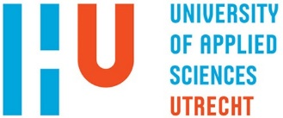
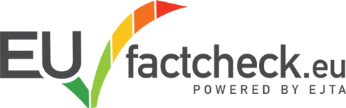

BIP EUfactcheck Elections Lab
BIP nr: 2023-1-NL01-KA131-HED-000126779-3

Participating Universities
1. HaagaHelia, Helsinki (Finland)
2. Universitat Autonoma Barcelona (Spain)
3. Thomas Moore, Mechelen (Belgium)
4. BBU, Cluj (Romania)
5. Jade, Wilhelmshavn (Germany)
6. Zagreb, (Croatia)
7. Mariupol (Ukraine)
8. GIPA (Georgia)
9. HU Utrecht (The Netherlands)
10. Stuttgart (Germany)

Objectives and Description
The EU Elections are just around the corner. With increased polarization, many national elections throughout Europe, hot topics like immigration and climate change plus the wars on our doorstep, the EU elections are an important timestamp during a young journalists’ study period. For most of the students taking part in this programme it will be their first time to vote. To prepare students to become informed voters, who can simultaneously inform an audience about relevant election topics and important themes would be the highest goal to achieve.
During the week (May) there are lectures and workshops about Europe, fact-checking, and working in diverse intercultural groups. There is also time for social interaction, this will assist in bettering the understanding of all the different perspectives that students from other parts of Europe (might) have on the most pressing issues within the EU.

Prior to the week students are introduced to each other in a virtual classroom (April). After the week, student-teams will continue to meet online to finalize their publication. A final virtual classroom during/after the EU elections (June) will complete the programme.
To sum up, the objectives are:
- To teach students about the EU elections and its most relevant themes;
- To teach students about fact-checking, including in-depth research and interviewing skills;
- To give students the opportunity to publish a fact-check on the EUFACTCHECK platform, for which they need to understand the genre and relate to the audience;
- To give students insights into working with a diverse team, which members have different perspectives on EU themes;
- To turn students into informed EU citizens AND into journalists who have a broader view and understanding of the EU and can relate this to an audience.

Methods and Outcomes
Students will work together in intercultural teams supervised by a lecturer who teaches and coaches students toward the publication of a fact-check on the EUfactcheck platform. The method used is a fact-check flowchart and fact-check format developed by the EUfactcheck collective and adopted by over 50 Schools of Journalism throughout Europe, and in the rest of the world. Students will be taught basic and advanced fact-checking skills and do in-depth journalistic research into a relevant EU Elections topic or theme from multiple perspectives. This will result in one or more publishable fact-checks on EUfactcheck.
Students will earn 3 EC nt for full participation and completion of the outcome (fact-check published). It will be visualized in a certificate and 3 EC registered via the BIP platform.

Planning overview

- Virtual Pre-meeting: 22-26 April, to be established between the participating schools, most likely we will pick a 2 hour timeslot at the end of a day.
- EUfactcheck elections lab week: 13-17 May, we will start on Monday morning around 10am, so all participants need to travel on Sunday afternoon at the latest.
- Virtual Wrap-up meeting: during or just after the EU elections (6-11 June)

